Design and Creation of a Geodatabase on the Colorado River Refuge Owned and Managed by Pines and Prairies Land Trust in Bastrop, TX
Created By: Arma-Geo Products

For: Pines and Prairies Land Trust

Geography 4427
Texas State University
October 3, 2012
Arma-Geo Products

Ryan Henderson: Project Manager

Dustin Sablatura: Assistant Project Manager

Veronica Suarez: GIS Analyst / Graphic Design

Marcos Montelongo: GIS Analyst / Webmaster

Geography 4427
Texas State University
October 3, 2012
Table of Contents

Introduction

Summary………………………………………………………… 1

Purpose ………………………………………………………….. 2

Literature Review ……………………………………...……. 2

Scope ……………………………………………………………… 3

Proposal

Data ……………………………………………………………….. 4

Methodology ………………………………………………….. 5

Implications …………………………………………………… 6

Budget …………………………………………………………… 7

Timetable ………………………………………………………. 8

Timeline graph ……………………………………………… 10

Final Deliverables ………………………………………….. 11

Conclusion …………………………………………………………… 12

Participation ……………………………………………………..… 13

References ………………………………………………...………… 14
Introduction

Summary

The Pines and Prairies Land Trust (PPLT) is a non-profit land conservation organization that serves Bastrop, Caldwell, Fayette, Lee, and eastern Travis Counties. Pines and Prairies Land Trust aims to protect various historical, natural, and cultural resources, while promoting sustainable wildlife and agricultural practices in Central Texas. Pines and Prairies Land Trust encourages these environmentally conscious values by educating the public and protecting the properties and easements under their management. Pines and Prairies Land Trust owns and manages multiple properties and easements located in Central Texas. PPLT has identified the need for a useful geographic information system along with additional geospatial data related to the properties. After viewing the request for proposal submitted by PPLT, Arma-Geo Products (AGP) has decided to design a geodatabase that can be used to store and visualize data on their properties and easements. Arma-Geo Products will also use this geodatabase to create several different maps of varying scale that PPLT has expressed a need for. An interactive map will also be created that will be imbedded within PPLT’s website.

Purpose
Having access to such a database while using GIS software like Arc Map will provide useful information that can guide future projects, and improve the management capabilities of PPLT. Displaying the various types of data we collect on the properties can create useful maps. These maps serve to scale and visualize the properties for their staff, visitors, and supporters. This geodatabase will make it possible for PPLT to create customized maps based on their own criteria. Having this geodatabase is also beneficial because it will associate descriptive attribute data with the spatial data. This allows PPLT to create customized tables of information that can be populated for bookkeeping and analysis purposes. In the future, PPLT can use interns or hired GIS analysts to perform additional projects using this geodatabase. This database and GIS will serve as a foundation of data that will support and streamline the efforts of PPLT in improving the quality and value of the Colorado River Refuge and their other properties.

Literature Review
After reviewing the request for proposal, Arma-Geo Products conducted a literature review in order to find valuable information regarding geodatabase design. Resources were found on proper GPS field methods, geodatabase design fundamentals, and a project that is similar to this one. These sources are listed in the references section of this report.

Scope
The scope of this project is based on the locations of the three PPLT owned properties that are managed for land, water, air, and wildlife protection. The Colorado River Refuge (CRR) located south of the city of Bastrop will be our primary area of concentration for creating a geographic information system. Additionally we are expected to collect GPS data on the various elements located within each of the preserves. The Yegua Knobbs Preserve (YKP), located North West of McDade, Texas and Billig Ranch (BR), near the city of Paige, Texas will be secondary areas of interest requiring the same concentration as CRR.

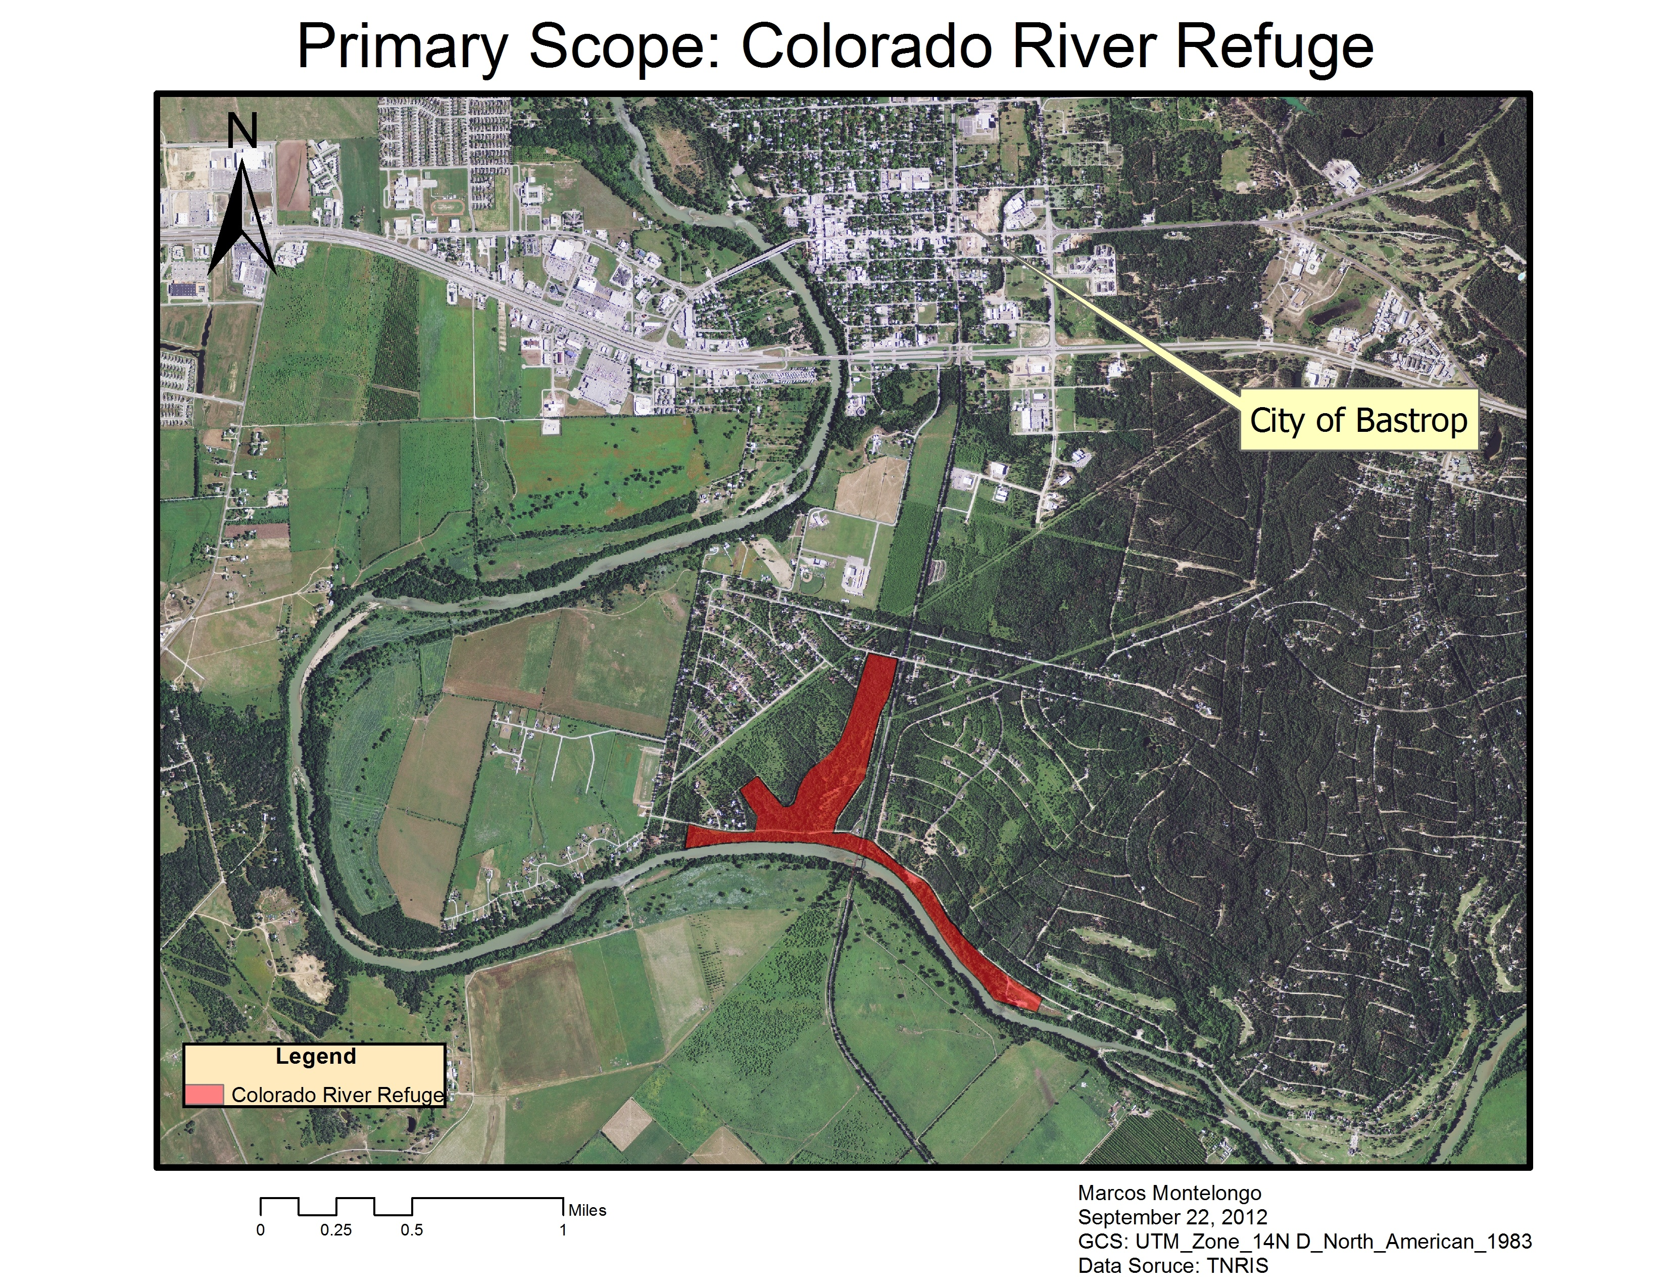
Proposal

Data

Data for this project will be provided in part by PPLT, gathered from online sources, or collected directly from the field by AGP. The client-supplied material varies in usability and is often missing spatial information. AGP will decipher which of the provided data will be useful in creating a GIS database for PPLT. Data that needs to be collected by AGP, such as trees on a particular trail, will include attribute data with fields for northing, easting, and tree type. AGP will also utilize remote sensing data when possible from sources such as Google Earth, which can then be transferred to Arc Map.
The following list describes specific data sources:

Colorado River Refuge boundary | Client Supplied
Billig Ranch boundary | Client Supplied
Yegua Knobbs Preserve boundary | Client Supplied
County boundary | TNRIS
DEM of Bastrop County | TNRIS
Waterways of Texas | TNRIS
Railroad Tracks of Texas | TNRIS
Texas Roads | TNRIS

Methodology

Since the primary goal of this project is to create a geodatabase for PPLT, the structure of our GIS is of utmost importance. After meeting with Melanie Snyder, Executive Director for PPLT, AGP has learned which features should be identified in the GIS. The major features to be delineated include: parking lots (polygons), trail head signs (points), trails (lines), handicap accessible areas (lines), bridges (lines), trail features (points), water diversion areas (polygons), ponds (polygons), gardens (polygons), benches (points). We will add any other features deemed relevant as well. All major features will be given a separate layer with tables that will define each unique feature. Depending on the quality of data AGP can collect, these attribute tables will include geographic coordinates and other levels of measurement deemed applicable.
Some of our data will likely have to be gathered from the field. In these circumstances will we use handheld GPS devices supplied by Texas State’s Geography department or by the PPLT office. If time permits, AGP will begin adding data from Billig Ranch or Yegua Knobbs Preserve to the database. The procedures taken in building the CRR database will be applied to these land tracts when possible.
While the majority of AGP’s work will focus on map features of CRR, we will also conduct analysis over slope and aspect of the project area. Although it is unlikely that the analysis will contribute to the final project deliverables, PPLT has expressed interest in having this information for future use. In addition to digital data in the form of a GIS database, PPLT has requested that Arma-Geo Products create hard copy maps for in house and public use. These maps may be printed onto brochures for public use of the CRR land tract.
A new venture for Arma-Geo Products lies in creating interactive maps. AGP will determine which method will best be suited for creating the interactive map. Once completed, we will link the map to the public through the web. Arma-Geo Products will conduct more research on creating the interactive map, and test the techniques and procedures to be used before delivering the final product to PPLT.

Implications

This project will meet the Pines and Prairie Land Trust’s request for the creation of a user-friendly geodatabase for the Colorado River Refuge, and potentially the Yegua Knobbs Preserve and Billig Ranch. This data will help coordinate other existing programs to combine nature walking trails, native vegetation, and Central Texas fauna. It can be used as a resource for planning projects within the properties, and as a reference for future decisions that may impact the quality of the three properties owned by PPLT. This study can also be used by various agencies and organizations like Texas Parks and Wildlife in their efforts to continue the preservation of natural habitats found throughout Texas.

PROJECT BUDGET

Data Collection/ GPS Fieldwork
Team Manager (1) Team Analysts (3)
Hours/ week: 12 Hours/ week: 10
Weeks: 4 Weeks: 4
Hourly wage: $25 Hourly wage: $20
Subtotal: $1200 Subtotal: $2400
Subtotal: $3600
Data Processing/ GIS Design
Team Manager (1) Team Analysts (3)
Hours/ week: 10 Hours/ week: 10
Weeks: 4 Weeks: 4
Hourly Wage: $40 Hourly Wage: $30
Subtotal: $1600 Subtotal: $3600
Subtotal: $5200
System Management
Project Manager Assistant Manager
Total Hours: 40 Total Hours: 30
Hourly Pay: $50 Hourly Pay: $40
Subtotal: $2000 Subtotal: $1200
Subtotal: $3200
Specialists
Web Master Graphic Designer
Total Hours: 25 Total Hours: 10
Hourly Wage: $35 Hourly Wage: $35
Subtotal: $875 Subtotal: $350
Subtotal: $1225
Equipment Costs
Supplies: ($150 per workstation * 4 workstations) $600
Maintenance: ($100 per workstation * 4 workstations) $400
Depreciation of Equipment: ($8000 value of computers / 36 months of life * 2.5 months of use for project) $555.56
Subtotal: $1,555.56
Software Costs
Arc GIS 10: ($25,000 ESRI License fee/ (12 months * 2.5months of usage) $5,208.33
Adobe Photoshop: $699
Subtotal: $5,907.33
Travel Expense
200 miles @ $0.50 /mile: $100
Subtotal: $100

Total Costs: $20,787.89
Timetable

The first four weeks of our allotted time was spent meeting our client and communicating with them to find out what they expected for a final outcome of this project. Once our team understood PPLT’s expectations for the final result, we set our focus on developing the project proposal and power point in order to convey our goal back to Tina and Melanie of PPLT. We feel that it is just as important, if not more, for them to know our intentions as it is for us to know their expectations.
Once we have successfully put together a high quality, informative proposal, we will begin the task creating the geodatabase. This step is being performed before the data is collected because we need to know how to group and organize the data before we collect it all.
Once a geodatabase has been created, we will then begin to collect our data. This will consist of mostly hands on fieldwork using GPS. Melanie and Tina provided us with a large number of shape-files, but after perusing the files, we found nothing of significance for the Colorado River Refuge, which is our main objective for the time being. We estimate that this process should take roughly 4 weeks. Once we have successfully collected the data by GPS (trails, park benches, high elevation points, and other significant features), we will begin the task of processing our data.
This involves quality checks, and preparing the data to be managed in a GIS. This should take us no more than four weeks. Due to time constraints, this task might overlap with the end of the data collection period. Then we move on to the website portion of the project.
The website should take us about three weeks to complete. During the creation of our website, we will also begin the preparation of our final deliverables. This will be the culmination of all of our efforts, so we allotted three weeks for this final step. Even with three weeks assigned to the final deliverables preparation, we should finish with at least a week left before the presentation date. This week will be utilized to revise and edit our final report.

Arma-Geo Products Timeline
Tasks | Weeks
 | 1 | 2 | 3 | 4 | 5 | 6 | 7 | 8 | 9 | 10 | 11 | 12 | 13
 | 9/3 | 9/10 | 9/17 | 9/24 | 10/1 | 10/8 | 10/15 | 10/22 | 10/29 | 11/5 | 11/12 | 11/19 | 11/26
Project Overviews/
Client Introduction
Project Proposal
Data Collection/ GPS Fieldwork
Data Processing
GIS Development/ Design
Website Development
Preparation of Final Deliverables

Final Deliverables

- CD/DVD containing the geodatabase and data
- Metadata
- Power Point Presentation
- Professional Posters for display at PPLT and Texas State
- Website
- Instructions for PPLT on how to use data on CD (readme file)
- Final Maps to be used for PPLT brochures and trail heads
- Final Report

Conclusion

This proposal describes the techniques and information Arma-Geo Products will use in order to design and implement a useful geodatabase that can be used for future analysis, project planning, and management. The database will contain spatial and descriptive data in regards to park boundaries and features found within the park. In addition to the geodatabase, Arma-Geo Products will provide Pines and Prairies Land Trust with various maps that will be used for brochures, posters, and park maps. An interactive map will also be designed and given to Pines and Prairies Land Trust for use on their website. We will review any data that was already collected by Pines and Prairies Land Trust, and personally collect any additional data needed on features within the Colorado River Refuge. Our project will be delivered to Pines and Prairies Land Trust in the form of a CD. This disc will contain all reports, maps, data, metadata, presentations, and instructions on how to use the CD. This proposal includes a timetable and budget. This project will include a final poster and CD that will be turned in to the Geography department. Our team hopes to provide the Pines and Prairies Land Trust with a useful set of information that can aid in future planning and development within the Colorado River Refuge. We believe our geodatabase design will provide Pines and Prairies Land Trust with a valuable resource that will expand their capabilities, and increase the success of their conservation practices.
Participation

Ryan Henderson (Project Manager)

- Literature review, summary, purpose, conclusion, references

Dustin Sablatura (Assistant Project Manager)

- Budget, timetable, graph timeline

Veronica Suarez (GIS Analyst, Graphic Designer)

- Logo design, data, methodology

Marcos Montelongo (GIS Analyst, Webmaster)

- Scope, implications, final deliverables, scope map

Our team collaborated in designing this project proposal, and each contributed our own sections contained within this document. Every member of the team will contributed to editing this proposal. Ryan Henderson, Project Manager, composed a literature review, composed the summary, purpose, conclusion, and references sections. Dustin Sablatura, Assistant Project Manager, designed the budget along with the timetable and graph timeline. Veronica Suarez, GIS Analyst and Graphic Designer, composed the data and methodology sections, and also designed the company logo. Marcos Montelongo, GIS Analyst and Webmaster, composed the scope, scope map, implications, and Final Deliverables sections.
References

Carillo, Jacqueline, Christensen, Scott, Dillashaw, Bradley, McGauhey, Kelly, and Ortega, Sam. 2011. Construction of Database for the New Braunfels Public Works Department. San Marcos, TX: Texas State University.

Baker, Michael, Jr. Updated GIS Database Design: Geodatabase Model. Virginia Beach, VA. http://www.suffolkva.us/gis/docs/database-design.pdf. (last accessed 29 September).

Perkins, Kent, and D., Robinson, Joshua. 2008. Best Practices for Collecting Geographic Data in the Field. Gainesville, FL. http://www.flmnh.ufl.edu/herbarium/methods/Georeferencingbestpractices.htm. (last accessed 29 September).

